Name: Rana Ahmed SE-2

Week 3 Lab Report

1. Part A — Namespaces and cgroups

Observations
Inside the container:
- The hostname was different from the host machine.
- The process list showed a limited number of processes, with the main process appearing as PID 1.
- The network interface and mount points were isolated.
- The cgroup file showed resource control groups.
On the host:
- The container process had a different PID.
A1 outputs:
root@575cc4a04199:/# hostname
575cc4a04199

root@575cc4a04199:/# ps -ef
UID PID PPID C STIME TTY TIME CMD
root 1 0 0 13:45 pts/0 00:00:00 bash
root 10 1 0 13:46 pts/0 00:00:00 ps -ef
root@575cc4a04199:/# ip addr
bash: ip: command not found
root@575cc4a04199:/# mount | head
overlay on / type overlay (rw,relatime,lowerdir=/var/lib/desktop-containerd/daemon/io.containerd.snapshotter.v1.overlayfs/snapshots/154/fs:/var/lib/desktop-containerd/daemon/io.containerd.snapshotter.v1.overlayfs/snapshots/153/fs,upperdir=/var/lib/desktop-containerd/daemon/io.containerd.snapshotter.v1.overlayfs/snapshots/155/fs,workdir=/var/lib/desktop-containerd/daemon/io.containerd.snapshotter.v1.overlayfs/snapshots/155/work)
proc on /proc type proc (rw,nosuid,nodev,noexec,relatime)
tmpfs on /dev type tmpfs (rw,nosuid,size=65536k,mode=755)
devpts on /dev/pts type devpts (rw,nosuid,noexec,relatime,gid=5,mode=620,ptmxmode=666)
sysfs on /sys type sysfs (ro,nosuid,nodev,noexec,relatime)
cgroup on /sys/fs/cgroup type cgroup2 (ro,nosuid,nodev,noexec,relatime)
mqueue on /dev/mqueue type mqueue (rw,nosuid,nodev,noexec,relatime)
shm on /dev/shm type tmpfs (rw,nosuid,nodev,noexec,relatime,size=65536k)
/dev/sdd on /etc/resolv.conf type ext4 (rw,relatime)
/dev/sdd on /etc/hostname type ext4 (rw,relatime)
root@575cc4a04199:/# cat /proc/1/cgroup
0::/

A2 outputs:
The container uses a PID namespace which isolates process IDs inside the container. Inside the container, the main process appears as PID 1. However, on the host system, the same process is assigned a different PID (5775 in this case). This demonstrates that containers do not create separate operating systems, but instead isolate process views using namespaces.

The host
PS C:\Users\Rana> docker inspect nsdemo --format "{{.State.Pid}}"
5775

The container
root@61e10d18f143:/# ps -fp 5775
UID PID PPID C STIME TTY TIME CMD
root@61e10d18f143:/# ps -ef
UID PID PPID C STIME TTY TIME CMD
root 1 0 0 14:02 pts/0 00:00:00 bash
root 12 1 0 14:07 pts/0 00:00:00 ps -ef

A3 The stress test
stress --cpu 2 --vm 1 --vm-bytes 220M --timeout 30
Namespaces provide isolation by separating what a process can see (such as processes, network, and filesystem), while cgroups control how much resources a process can use (CPU, memory, I/O). Together, they allow containers to be both isolated and resource-limited, ensuring stability and fairness in shared systems.

3. Part B — Docker Image Layering

Observations
- The basic image was larger in size.
- The multi-stage image was smaller and cleaner.
- When modifying only app.py, Docker reused cached layers except for the final step.

Explanation
Docker images are built in layers. Each instruction creates a layer that can be reused if unchanged.
1.The basic image to compare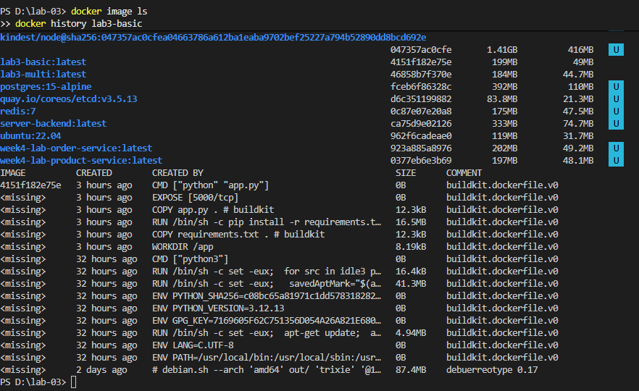

2. The multistage image
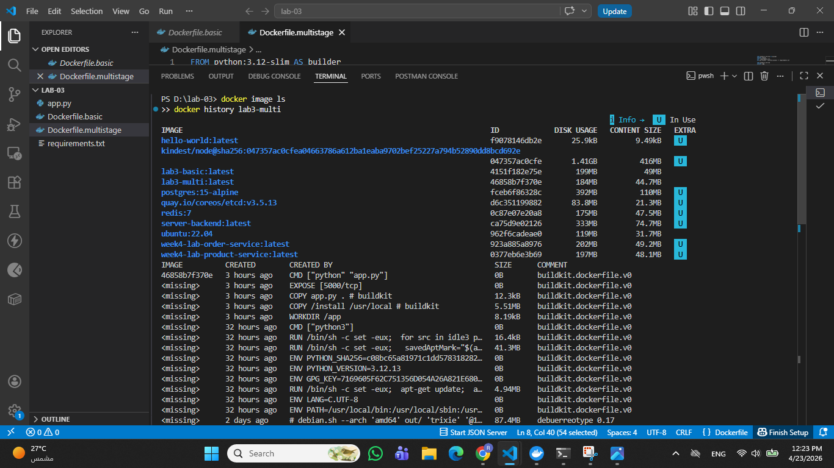

The multi-stage image is smaller because it only copies the necessary runtime dependencies and excludes build files.

Which steps are cached?
All layers before copying app.py are cached. Only the last layer is rebuilt when app.py changes.

Why does layer order matter?
Because Docker caches layers. If frequently changing files are placed early, cache is invalidated, increasing build time. Placing stable steps first improves efficiency.

PART C — Kubernetes (kind)
The cluster info and nodes is ready

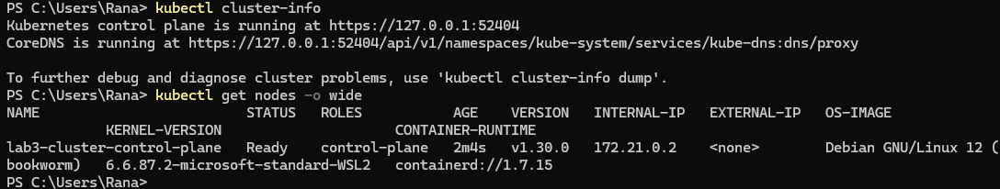
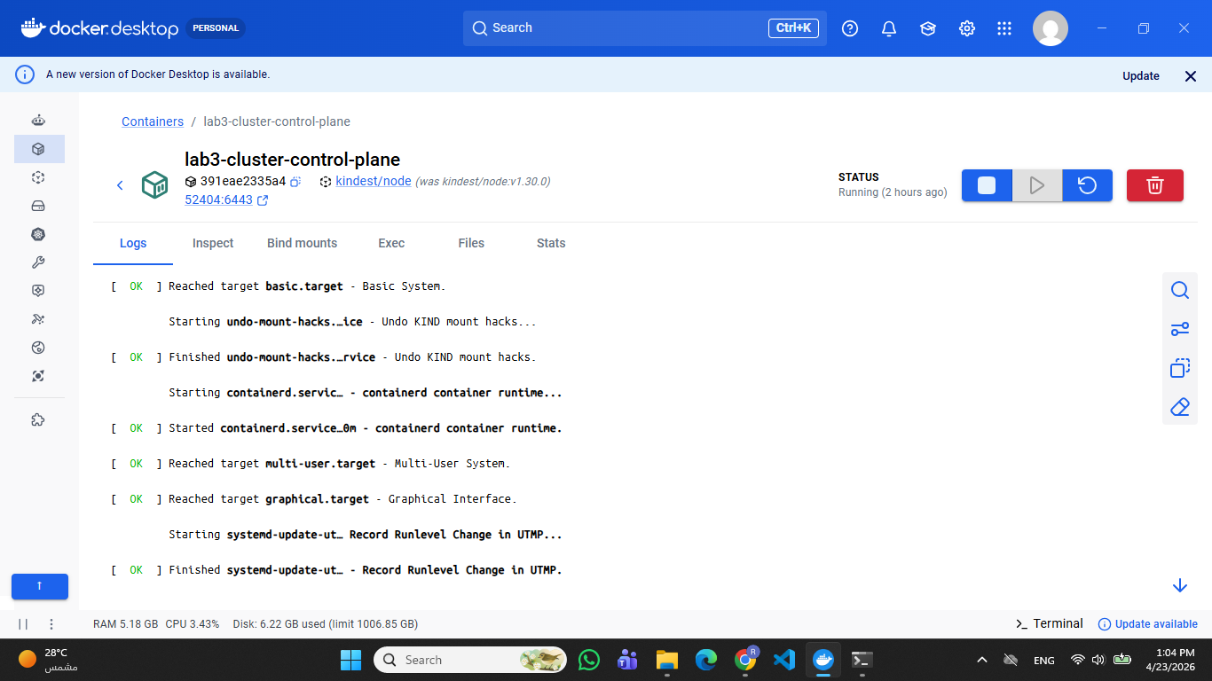

C2 Loaded the images into kind
C3 Created Deployment 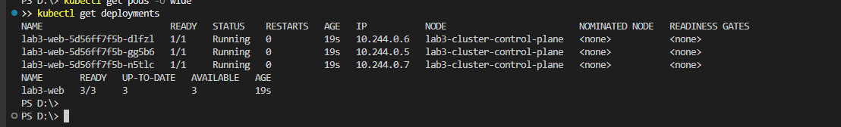
C4 Created Service 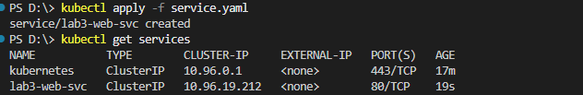
C5 Access the app
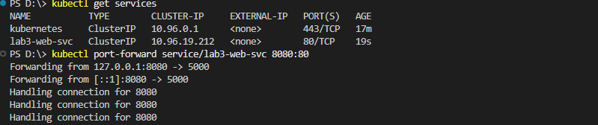
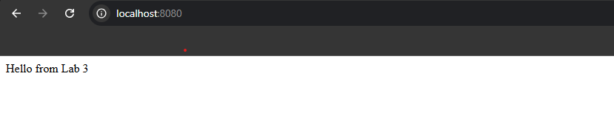
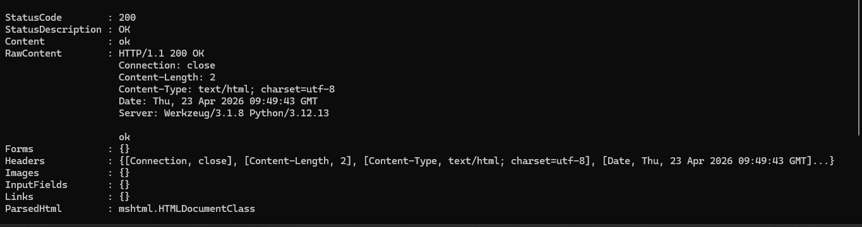Here the deployment defines the desired state (3 replicas). Kubernetes automatically creates and maintains these pods. The scheduler assigns Pods to nodes, and the Kubelet ensures they are running.

Part D1 Label the node
D2
Now node selectors allow declarative scheduling based on labels rather than fixed machine names. This improves flexibility, scalability, and resilience because workloads can be dynamically assigned to any suitable node instead of being tied to a specific machine.

E1 Delete a Pod (self-healing)
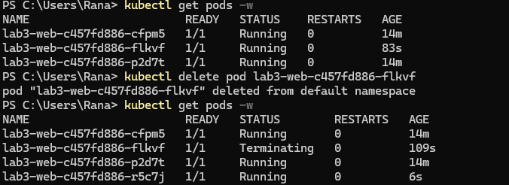
Kubernetes uses a reconciliation loop. When a Pod is deleted, the deployment controller detects the difference between the desired state and the current state and automatically creates a new pod to restore the system.
E2 probe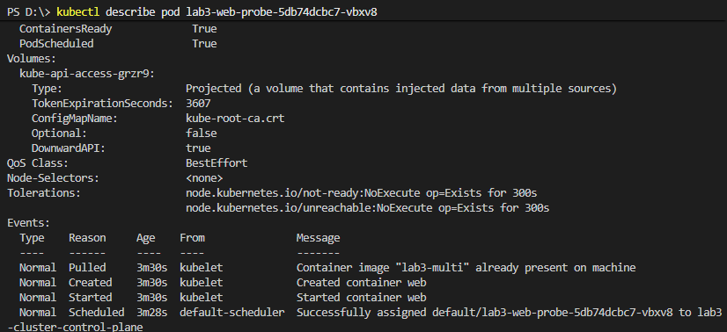

Reflection Answers

1. Why do namespaces alone not guarantee fair resource use?
Namespaces only provide isolation by separating what processes can see, such as processes, network, and filesystem. However, they do not control how much CPU, memory, or other resources a process can consume. Without limits, a container could use excessive resources. Therefore, namespaces alone cannot ensure fair resource usage.

2. How do cgroups improve cluster stability?

Cgroups enforce resource limits such as CPU and memory for containers. By preventing any single container from consuming excessive resources, cgroups ensure that all applications receive fair resource allocation, which improves system stability and prevents resource exhaustion.

3. Why is Docker image layering important for large-scale orchestration?

Docker image layering enables efficient storage and reuse of image components. Layers can be cached and shared across multiple images, reducing build time and storage usage. This is especially important in large-scale systems where many containers are deployed frequently.

4. What does Kubernetes mean by desired state?

Desired state refers to the configuration defined by the user, such as the number of replicas or application settings. Kubernetes continuously monitors the system and ensures that the current state matches the desired state using reconciliation mechanisms.

5. How is self-healing different from traditional manual operations?

In traditional systems, failures require manual intervention to restart services or fix issues. In Kubernetes, self-healing automatically detects failures and restores the system to the desired state by restarting containers or recreating Pods without human intervention.

6. Why are readiness probes and liveness probes not interchangeable?

Readiness probes determine whether a container is ready to serve requests, while liveness probes determine whether a container is still functioning correctly. A readiness failure stops traffic to the container, while a liveness failure triggers a restart. Since they serve different purposes, they are not interchangeable.

7. What is one limitation of observing scheduling in a single-node kind cluster?

In a single-node cluster, all Pods are scheduled on the same node, so it is not possible to observe real scheduling decisions across multiple nodes. This limits the ability to evaluate load balancing, fault tolerance, and placement strategies.

